|  |  |  |  |
| --- | --- | --- | --- |
|  | | | |
| **ESME Sudria**  Résultat de recherche d'images pour "javascript"Résultat de recherche d'images pour "meteor node"**Ecole speciale de mécanique et d'électricité**    Résultat de recherche d'images pour "react native"  Résultat de recherche d'images pour "node.js" | | | |
|  | | |
|  | **Term PROJECT:**  Development of a mobile application Cookin | |
|  |  |  |

**AUTHOR:** Stéphane NABHAN

**ADVISOR:** mr. abdulhalim dandoush

# Sumary

1| Sumary 2

2| abbreviation and keywords 4

3| INTRODUcTION 5

4| Application features 6

4.1| Basics cases 6

4.1| Cooker mode 7

4.1| Gourmet mode 8

5| Introduction Javascript and differents frameworks 9

5.1| Javascript **Erreur ! Signet non défini.**

5.2| React-native 9

5.3| Meteor 9

5.3.1| Isomorphic code: browsers and mobile 9

5.3.2| Full stack and automatic update of data 9

5.3.3| The real-time web 10

5.4| Mongo 10

5.5| Amazon Web Service (AWS) 11

5.5.1| Amazon EC2 presentation 11

5.6| Github 11

6| DEVELOPMENT OF THE CLIENT side 13

6.1| Architecture of the project 13

6.2| Module incorporation 14

6.2.1| React-native Navigator 14

6.2.2| No-native components 14

6.3| Communication with the server 15

6.4| Notification service 15

6.5| Design 18

7| Server 18

7.1| Database Management System 18

7.1.1| Using MongoDB 18

7.1| Presentation of collections 19

7.1.1| User 19

7.1.1| availableMenu 20

7.1.2| Order 20

7.2| Meteor 21

7.2.1| Function : **Erreur ! Signet non défini.**

7.2.2| Communication to the client (publish and subcribe methods) 21

7.2.3| Connexion with Facebook 22

8| DeploYment 23

8.1| Meteor server 23

8.1.1| Creating and configuring an Amazon EC2 instance 23

8.1.2| Presentation and configuration of Meteor Up (Mup) 24

8.2| Mongo Database 25

8.2.1| Installing MongoDB on the Same Instance as the Server 25

8.2.2| Installing MongoDB on a Mongo Atlas Cluster 25

8.2.3| Installing MongoDB on an Amazon EC2 cluster 26

8.3| Google Play Store 27

9| monitoring 28

9.1| Kadira 28

9.1.1| Presentation of Kadira 28

9.1.2| Linking to our server 28

9.2| Administration of the database 29

9.2.1| Studio3T utilisation 29

10| results 30

11| conclusion 35

12| literaTures 36

13| APPENDIX 37

13.1| APPENDIX 1: Stylesheets 37

13.1| APPENDIX 2: Communication Client - Server 37

13.2| APPENDIX 3 : MUP Configuration for à local MongoDB 39

13.3| APPENDIX 4 : MUP Configuration for a Mongo Atlas Utilization 40

13.4| APPENDIX 5 : Example of user fields in RobotMongo 40

13.1| APPENDIX 6 : CreateContainer 41

# abbreviation and keywords

|  |
| --- |
| **IP address:** An IP address (with IP for Internet Protocol) is an identification number assigned permanently or temporarily to each device connected to a computer network using the Internet Protocol. The IP address is the basis of the routing system messages across the Internet.  There are IP version 4 (32 bits) and version 6 (128 bits). Version 4 is currently the most widely used: it is generally represented in decimal notation with four numbers between 0 and 255, for example: 172.16.254.1    **PORT:** Corresponding to the transport layer of the OSI model, the notion of software port allows, on a given computer, to distinguish different interlocutors and services. These interlocutors are computer programs which, depending on the case, listen to or transmit information on these ports. A port is distinguished by its number.  **LAN:** LAN (Local Area Network) refers to a local computer network that connects computers in a limited area such as a house, school, computer laboratory, or office building. As opposed to WAN (wide area network).  **SDK:** SDK is the English acronym for Software Development Kit. An SDK is a set of programming tools available to publishers / developers of mobile applications. Many SDKs are used in the development, editing and management of mobile applications. Currently, with use the SDK API 22 for your application  **DATABASE:** A database is a collection of information that is organized so that it can be easily accessed, managed and updated.  Data is organized into rows, columns and tables, and it is indexed to make it easier to find relevant information. Data gets updated, expanded and deleted as new information is added. Databases process workloads to create and update themselves, querying the data they contain and running applications against it.  **SERVER:** A server is a computer program that provides services to other computer programs (and their users) in the same or other computers. The computer that a server program runs in is also frequently referred to as a server. That machine may be a dedicated server or used for other purposes as well.  In the client/server programming model, a server program awaits and fulfills requests from client programs, which may be running in the same or other computers. A given application in a computer may function as a client with requests for services from other programs and also as a server of requests from other programs. |
|  |

# INTRODUcTION

After the discovery of several frameworks allowing the development of cross-platform applications (Android / iOS etc.) in JavaScript, I decided to use one of these frameworks and our knowledge in JavaScript to create an application.

Being also attracted to entrepreneurship and the creation of Startups, the development of a mobile application is a skill that I cherished, and I wanted to be able to realize this in autonomy and learn by myself.

Interested in mobile development, I wanted to create the skeleton of a real application: its architecture, its server, its database and the functioning of these different modules which was quite unknown to us at the start.

In addition, I always thought it was unfortunate that such a concept does not exist. Indeed, today millions of people have cooking and cooking skills more or less pronounced.

In addition, millions of people would like to eat good home-made dishes, to recover close to home and especially for little money.

So, I decided to create a linking app for Cooks (which I call "Cookers" in my app) and customers.

Cooks can more easily make real cooking without worrying about leftovers or spending time cooking for small portions. Moreover, this concept makes it possible to avoid waste by selling its surplus of food rather than storing it and losing its freshness.

Finally, I try to highlight the cuisine of the world. The possibility of buying good traditional dishes to cooks from the country in question.

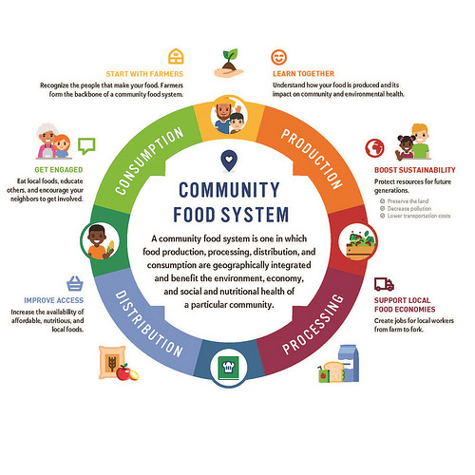

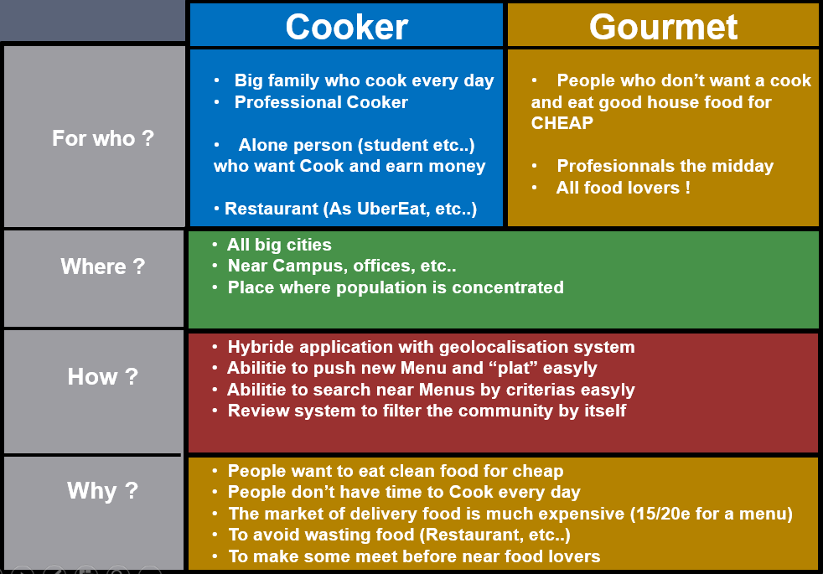

There are many cases of possible uses for this application, the student without a lot of money who would like to earn or buy inexpensive dishes to the kitchen professional who would like to start his own business through the mother family who cook in quantity every day and would like to earn money.

It is a rather complete project, since it passes through the prototyping of the application, the realization of the client (the front), the realization of the server (the back), the security aspect, the management of a database and the implementation of monitoring to administer the application

# Application features

## Basics cases

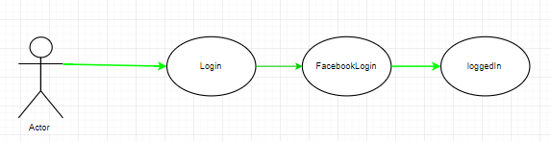

*Login with Facebook API*

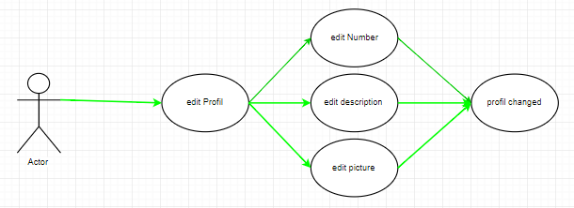

*Edit profile*

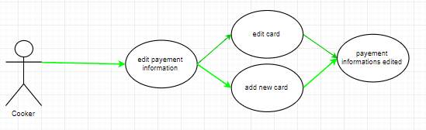

*Edit payment information*

## Cooker mode

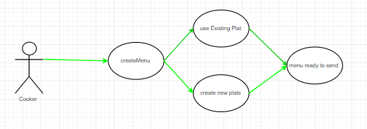

*Create a new menu*

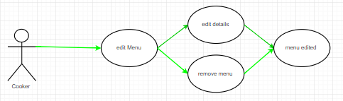

*Edit an existing menu*

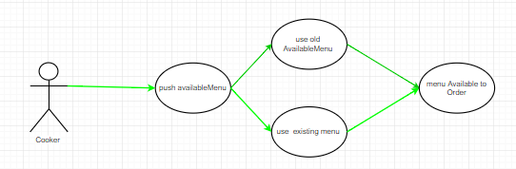

*Push a new available Menu for everyone*

## Gourmet mode

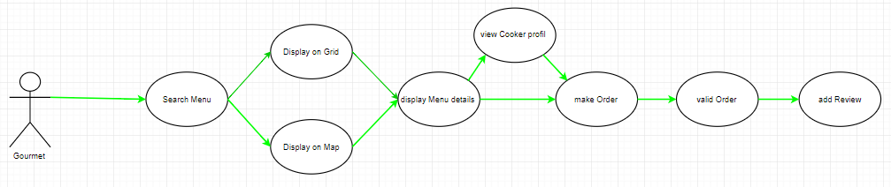

*Search an available Menu using criteria, abilities to view Cooker profile, Reviews, etc. When the Order is validated, the customer is allowed to add a new review.*

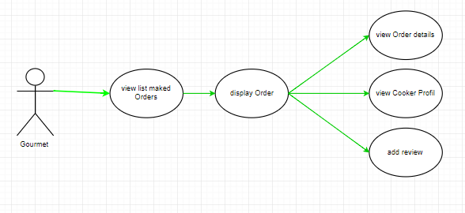

*The customer can see all his ended orders. He can edit his reviews, see the details, etc.*

# Introduction Javascript and differents frameworks

## JavaScript

Created in the mid-90’s as a simple script language, JavaScript is one of the most used language in the development of web applications.

I developed our application using WebStorm as an IDE, I chose this one because it is the one our JavaScript teacher Mr. Robin advise us to use and

I decided to use JavaScript, but I could have used Java to create an Android application or Swift for an iOS application, but I decided to use JS to be able to use React Native and create a Native application that can be run on both OS.

## React-native

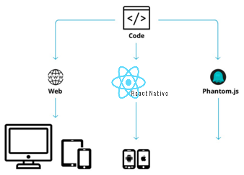React Native libraries were announced by Facebook in 2015, providing the React architecture to native iOS, Android and UWP applications.

React Native have a lot of useful features, like hot reloading which allow us to reload our application in one click instead of recompiling the app, you can also use native components written in objective-c or java in your React Native application.

Even though React Native is a recent library, the documentation is well written and updated every month, there are also many tutorials to create your first React Native application.

## Meteor

### Isomorphic code: browsers and mobile

As its description suggests, Meteor can create cross-platform applications. Web apps for browsers and native hybrid applications for iOS and Android through the integration of React-native.

At least, it is possible to build libraries to share features, the user interface remaining to optimize for each platform.

### Full stack and automatic update of data

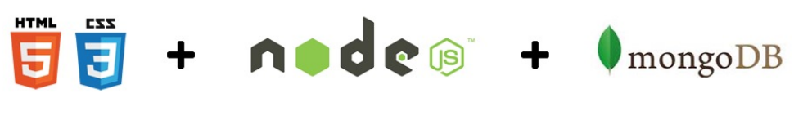Meteor is JavaScript everywhere, from client to server. The code can therefore be shared for both runtime environments. The framework also integrates a MongoDB database. On the client side, I find his counterpart MiniMongo. This is where the data waiting for synchronization will be temporarily stored. This device improves the reaction time of the application.

The data synchronizes with the server and updates to the screen. No need to refresh the page.

### The real-time web

The actions of a user are instantly visible in his interface and the actions performed by other users are visible the time to cross the web to him.

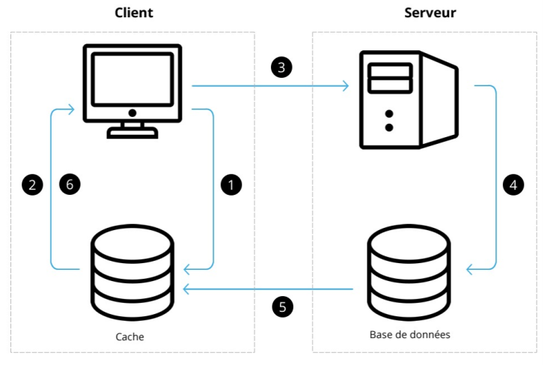

**User action modifying the local cache:**

1. Updating the client interface

2. Sending the request to the server

3. Verification of data and registration in the database

4. Returns the result to the client cache

5. Updating the Client Interface

## Mongo

**MongoDB** is a free and open-source cross-platform document-oriented database program. Classified as a NoSQL database program, MongoDB uses JSON-like documents with schemas.

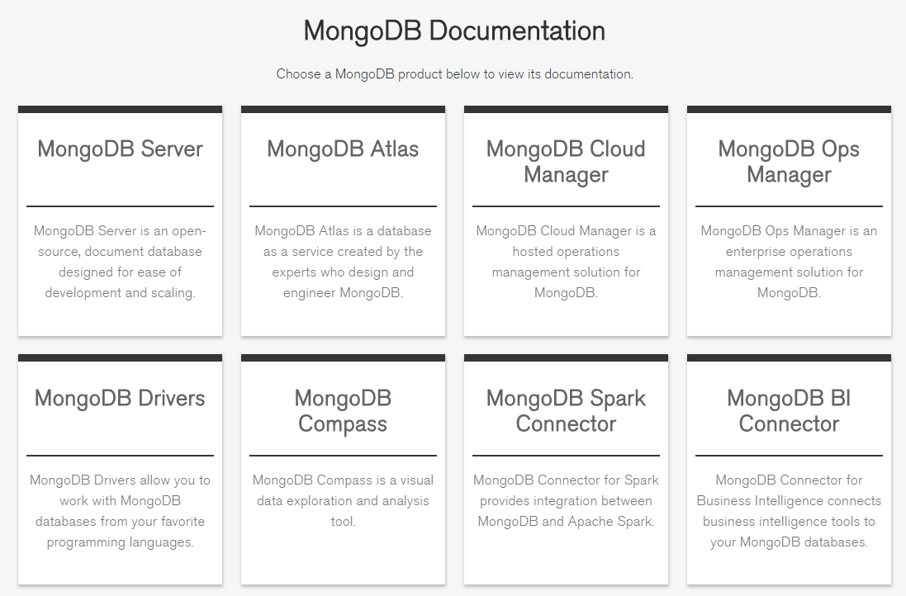

## Amazon Web Service (AWS)

### Amazon EC2 presentation

Amazon EC2 is a server instance service managed by Amazon. It offers a free trial of 12 months which was perfect for our tests. Different sizes and configuration of instances are proposed, with different kernels (Amazon Linux, Ubuntu Server, Windows Server, etc.):

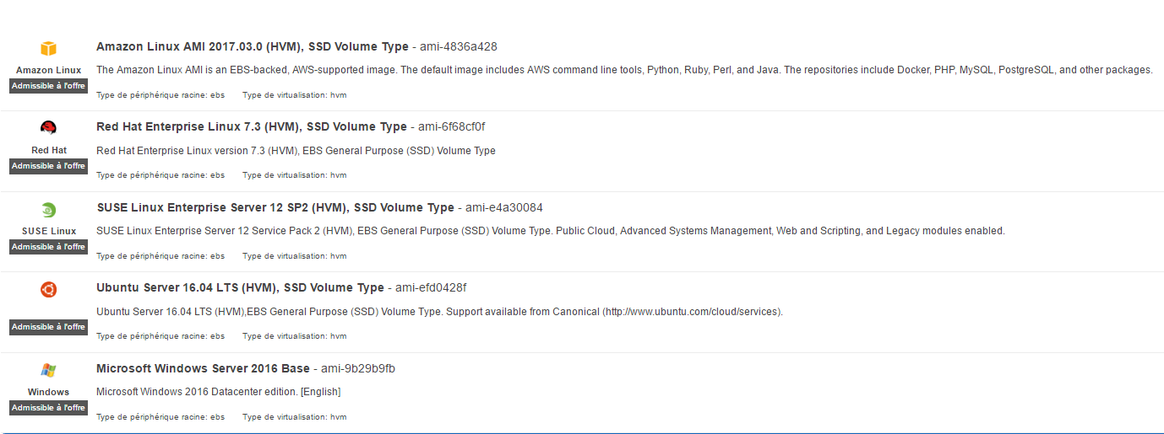

A large community exists, with many instances developed by freelancers in open-source. However, the free use of Amazon did not allow us to access this community and I wanted to realize the whole installation from a simple Linux kernel.

I work locally for development, but I decided to use this service to deploy our server in the cloud.

## Github

GitHub is a web-based Git and Internet hosting service that offers all the distributed version control and source code management functionality of Git as well as adding its own features.

During this project, GitHub has been a powerful and helpful tool, I created a repository right after I choose to develop a mobile application. I decided to keep our repository clean, to create a new branch for each feature I implemented and to merge it with the main branch after the development was finished.

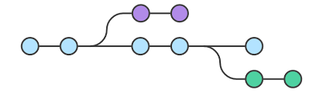

In the schema above, le blue branch represents our master branch and the green and purple ones represent the different features.

I use bitbucket, which allow private repository for free (instead of GitHub). It based on the GitHub engine. In the repository dashboard you can access all the directories and files of the projects, you can also see all the commits of the contributors of the project and see what they changed in the different files:

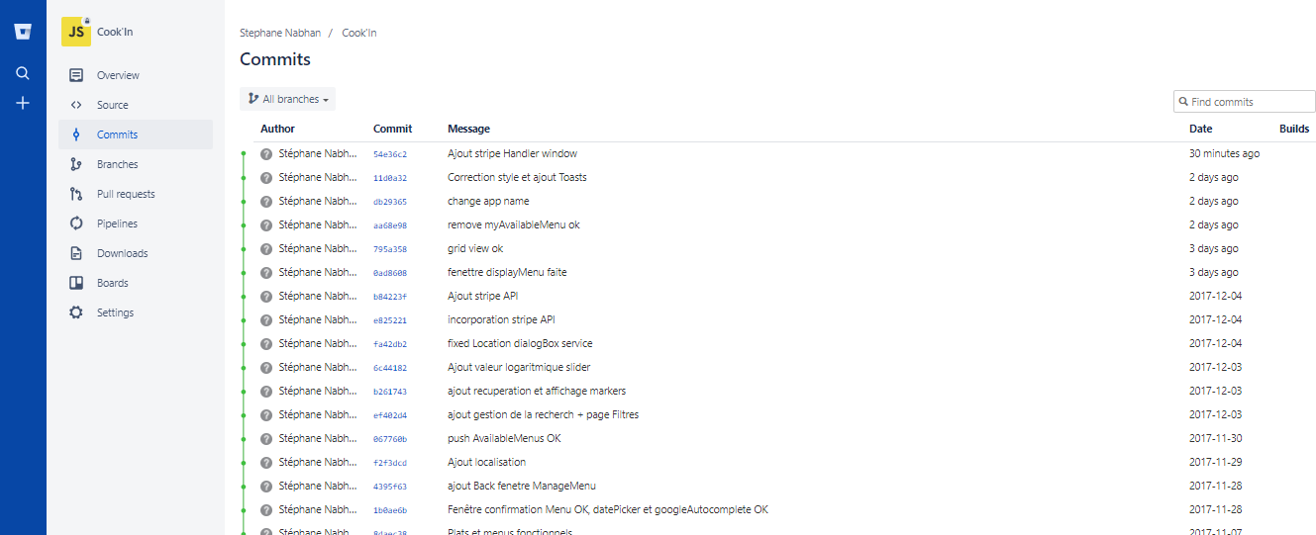

# DEVELOPMENT OF THE CLIENT side

## Architecture of the project

In the client side, we organized my code with several types of entities, actions, components, navigators, styles, etc...

In the Manager directory there is the Manager who handle connection with the server.

The Navigator directory contains all the navigators used by the application.

The navigators allow the navigation between the different views and finally the Forms are all the Views where the user must complete text inputs.

The styles directory contains all the stylesheets used by the different views.

Component directory contains all the components that I used in the code.

I decided to choose this architecture to keep our code clean and to know exactly where to put every file.

I also have all the native configuration files, presents in IOS and Android directories.

In addition, the configurations files used by Github and NPM.

## Module incorporation

### React-native Navigator

In this part we will see how does the Navigator component of React-Native works and especially how the Navigator component allowed us to create a reactive and simple to use application with a simple and ergonomic way of navigating between views.

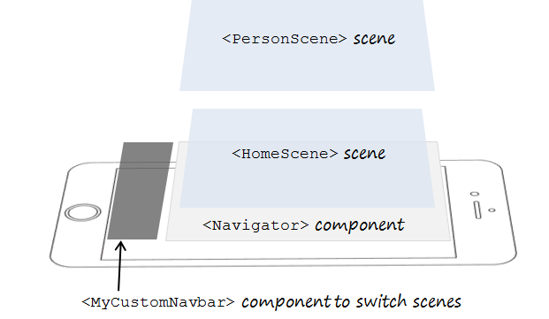

The Navigator works like a stack of views, when you use the **pop()** method of the navigator, it brings back the last view of the stack as shown in the following schema:

The schema above represents the way our app works, a navbar to navigate between the profile navigator, the matching navigator and the messenger navigator, each of those navigators have several views (scenes) that can be pushed to the top of the stack and be seen by the user.

### No-native components

One of the many strength of React Native is that there are a lot of **npm modules** that I can use instead of creating them from scratch.

In this application, I use many ones like **One Signal** for the notification, r**eact-native-charts**, **react-native-TabBar** and many more.

These modules are really easy to install (except for **OneSignal** but it will be presented later),

in fact, for a module named MyModule, execute the command:

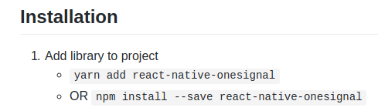**npm install –save MyModule**

And the module will be linked to the project, the modules are simple to use which is, most of the time, due to the developers of these modules who made great documentations and simple examples of how to use their modules.

## Communication with the server

**Cf APPENDIX 6: CreateContainer**

***Collection*allow to set on which collection I want to work:**

* selector [string / object], permit to find a specific document/object in the collection.

In this example, the selector is written to return user, who have a level between plus or minus one of our level, and not return our user.

* options object, in our example there is returned only five documents find.

Meteor also offers the ability to call functions asynchronously directly from the client.

We can pass arguments to its functions (to send data to the server), which can also return (to send data from the server to the client).

*Cf part 6.2.1 for more details*

## Notification service

In this part I will introduce the tools I used to let devices communicate between each other’s,

to make this happen, I used the **OneSignal** push notification system.

**OneSignal** is a high and reliable push notification service for websites and mobile applications that support all major native and mobile platforms by providing dedicated SDKs for each platform and an online dashboard for marketers to design and send push notifications.

First, I had to create a **OneSignal** account and configure the android application and link it to **OneSignal**, to do so, I needed a Google server API Key and a Google Project number.

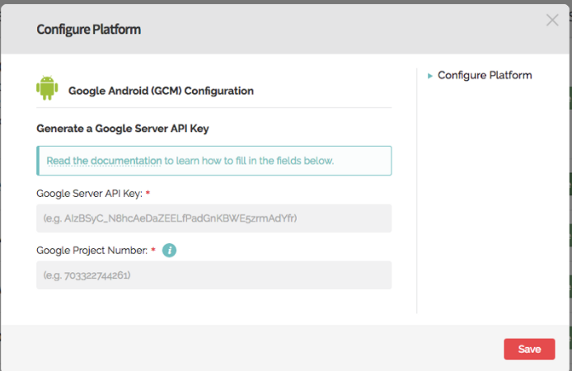

To generate this key and this number, Google Service Wizard is used, and cloud messaging is selected to Generate the data I want.

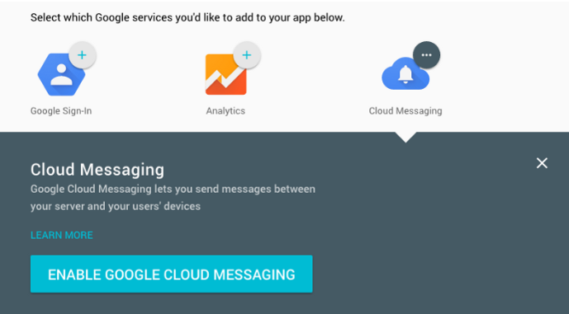

The first part of the work was now done, I introduced our application to **OneSignal**, but now I had to introduce **OneSignal** to our application because it didn't know it.

First, I had to install the **npm package** of **OneSignal**, I did it by using the following command:



After that, I add some permissions in the AndroidManifest.xml to allow **OneSignal** to send push notifications for example, I also gave to the build.gradle the **OneSignal** Id of the app and the Google Project Number.

Now the application and **OneSignal** knows each other’s and I can see all the linked devices in our Dashboard.

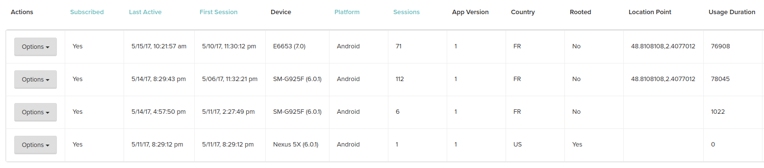**OneSignal dashboard:**

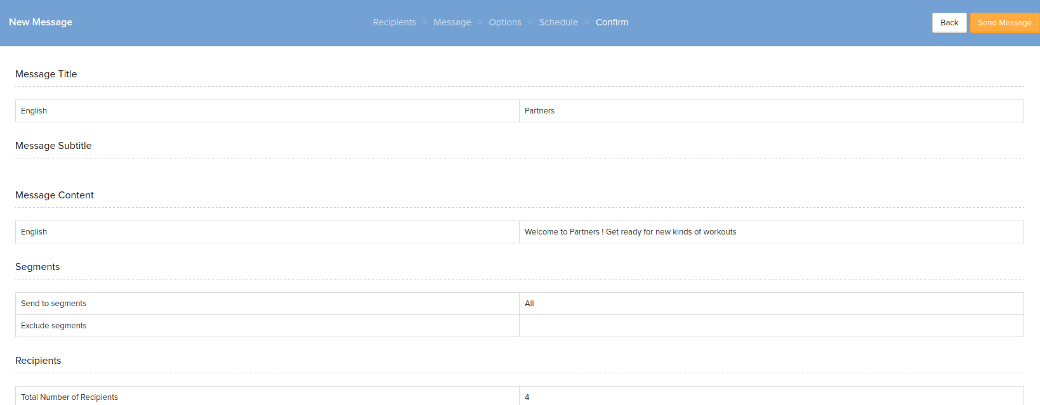 I have two different ways to send notifications to those devices, the first one is by using the OneSignal’s website dashboard:

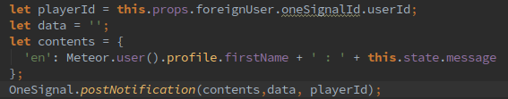Or I can sent notifications between devices like in this example:

In this example, the playerId is the OneSignal Id of the user to send a message to,

the content is like: “Adrien: Adrien’s message” so the user who received a message can read it on the notification.

The data field is useful if we want to add some options to our message like a special logo or a background image.

Once I send the notification, I have a monitoring tool where I can see when the notifications are clicked, who received them and if there has been any problem.

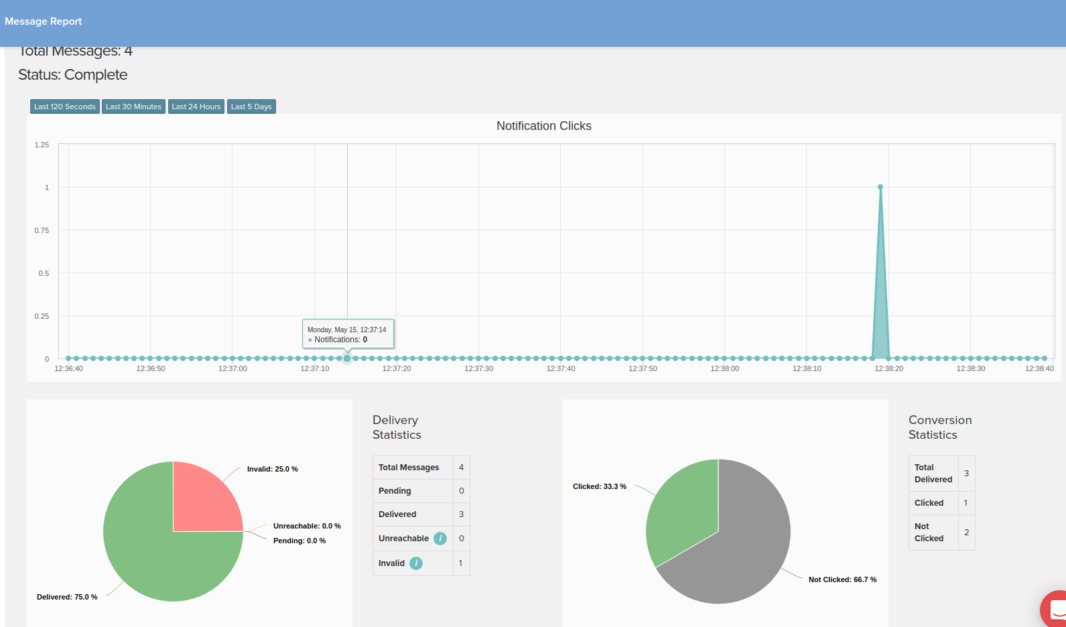

## Design

With React Native, we didn’t use any special language or syntax for defining styles, I just styled our application using JavaScript.

All the core component accepts a prop named style, the style names and values usually match how CSS works on the web.



In the example above, I apply to the **TouchableOpacity** (which is a button) the style “button” which is contained in.

# Server

## Database Management System

### Using MongoDB

Data in MongoDB has a **flexible schema**. Unlike SQL databases, where you must determine and declare a table’s schema before inserting data, MongoDB’s collection do not enforce document structure. This flexibility facilitates the mapping of documents to an entity or an object. Each document can match the data fields of the represented entity, even if the data has substantial variation. In practice, however, the documents in a collection share a similar structure.

A record in MongoDB is a document, which is a data structure composed of field and value pairs. MongoDB documents are similar to JSON objects. The values of fields may include other documents, arrays, and arrays of documents.

MongoDB stores documents in collections. Collections are analogous to tables in relational databases. Unlike a table, however, a collection does not require its documents to have the same schema.

## Presentation of collections

For the application I have defined 3 collections: **users, availableMenus and orders**

### User

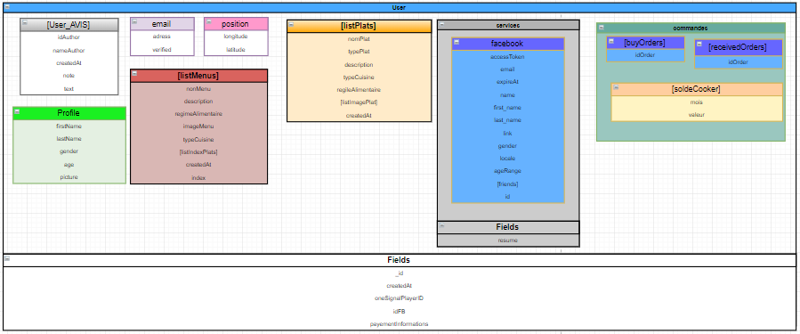

*Presentation of the user collection*

**In users’ collection there are four sub schema:**

* Profile schema where I store all data about the user (name, age, weight, size…).
* Email schema, there is the address and a Boolean for confirmed if the email is verified or not.
* Rating schema, I store all opinions and note given by the other users.
* Services schema, I store the Token and the password crypted
* Position schema, with the latitude and longitude in String format.
* ListMenu, an Array containing all menus of the user
* ListPlats, an Array containing all plats of the user

**And simple fields as:**

* _id (Mongo ID)
* createdAt
* oneSignalPlayerID
* IdFB (Facebook ID)
* Payment information (which will become a sub schema)

### availableMenu

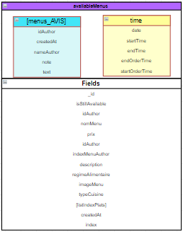

**In availableMenu’ collection there are two sub schema:**

* Time schema, where all data about the time (startOrder, endOrder etc..) are stored
* Rating schema, I store all opinions and note given by the other users.

*Presentation of availableMenu collection*

### Order

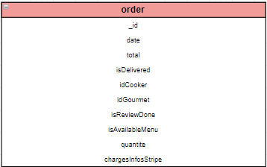

In the Order collection we can find all information about the Order. The date, the total, the state (delivered or not) the Cooker and Gourmet Ids etc. The Id of this collection is stocked in the order arrays in the User collection.

## Meteor

### Function:

Meter allow the ability to call functions asynchronously directly from the client, allowing data to be sent in both directions.

I can thus process the data in Node functions and then store them in the database or send them back to the client. It also allows me to manage call flow of functions in logs.

**Cf APPENDIX 2: Communication Client - Server**

### Communication to the client (publish and subscribe methods)

These functions control how Meteor servers publish sets of records and how clients can subscribe to those sets.

To publish records to clients, call **Meteor.publish()** on the server with two parameters:

* The name of the record set,
* A publish function that Meteor will call each time a client subscribes to the name.

Publish functions can return documents in the collection in function of the cursor**,** a cursor permits to filter the collection, and return only the data what I want. In which case Meteor will publish that documents to each subscribed client. it can also return an array of **Collection.Cursors**, in which case Meteor will publish all the cursors.

*Meteor*.publish('usersPartners', **function** () {

**return** users.find({'this.userId'},

{fields: {partners: 1}

});

});

*An example, return all partners Id of the current user. The field partners contain an array of userID*

### Connection with Facebook

Before to start to code anything, I downloaded some packages with the command:

**meteor add accounts-facebook service-configuration accounts-ui**

Once that’s done, it creates a **setting.json** file in your Meteor app directory. I’ll used that to store our Facebook settings info.

* **First step:** Creating the Facebook App, I must register my app on:

<https://developers.facebook.com/apps/>

After that, there are an appId and an app secret where I must put in the **settings.json** file created.

* **Second step:** Connecting meteor with the settings entered in the .json file.
* **third step:** React Native part, (client side), there are some packages to install:

**react-native install --save react-native-fbsdk**

**react-native link react-native-fbsdk**

* **fourth step:** react-native Android Setup, I have to configure our Facebook app for Android. Which is explain on the Facebook developers page step by step:

<https://developers.facebook.com/docs/android/getting-started>

* **Fifth Step:** Following the **ServiceConfiguration,** I’m registering a new login handler for Meteor. This allows us to call:

***Meteor.call(login, {facebook: data});***

where data is what I get back from the Facebook SDK. It then tries to fetch data about the user from Facebook

**This serves two purposes:**

* Tt checks the validity of the access token that was passed to our application
* Tt grabs some information for us to build the profile for the user. Lastly it checks if that user already exists in the database, if so then I log them in and update their info otherwise I create a new user for them I take profile picture, age, localization, firstname/lastname and the gender.

The last thing I have to do when registering a login handler is return an object with the userId.

* **Sixth step:**  Create button in the client side to login in calling the function login explain above, and the logout button where I call a **Meteor.logout().**

# DeploYment

## Meteor server

### Creating and configuring an Amazon EC2 instance

Creating an Amazon EC2 instance is quite simple, I just have to select the kernel of our choice as well as the performance. I will choose an **Ubuntu Server 16.04** kernel for setting up the Meteor server.

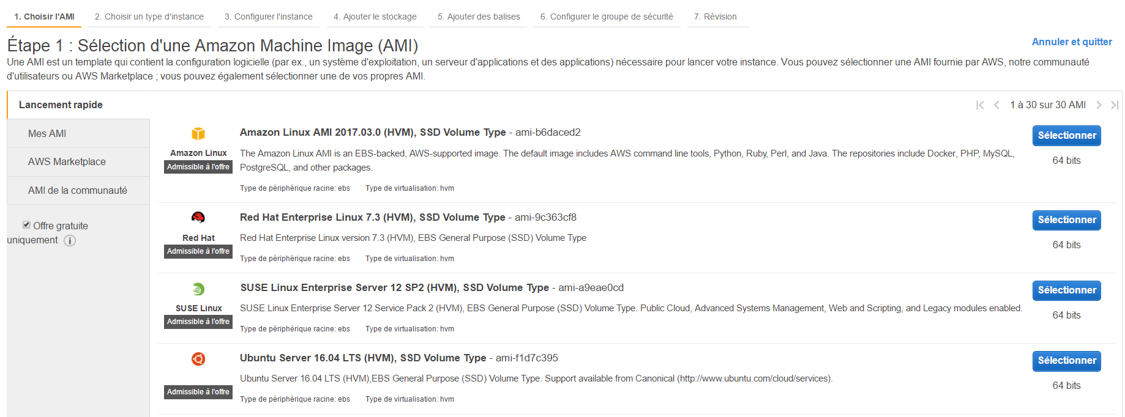

Then I have to generate a key pair (in. pem format) for the security of SSH access to our instance.



Then It is necessary to create a security group that is a kind of firewall, allowing to limit the incoming and outgoing traffic according to the client IP addresses and the ports used. I will just limit the incoming traffic:

* **Protocol SSH on port 22:**  for the instance's administration
* **TCP protocol on port 27017:**  for communication with the MongoDB database
* **Protocol TCP on port 80**: for communication with the client



The source IP addresses are open to the world because I do not know from which address a client might want to try to connect.

**Others security are of course provided:**

Access to the database is done by means of a secure authentication. The administration of the instance can only be done with the protocol SSH on the port 22, which is secured with a pair of private keys (.pem files) that I am the only ones to possess.

**As the instance is configured, it only remains to deploy Meteor on.**

### Presentation and configuration of Meteor Up (Mup)

Meteor Up is a deployment system offered by Meteor. It allows the deployment of a Meteor application on any server instance in the world.

To do this, I use a first initialization command Meteor Up to generates 2 files:

**• setting.json :** Similar to the setting file specific to each Meteor application, it allows to set some parameters during the bundle of the application. In our case, it contains a link to the Facebook application as well as a link to Kadira (an application allowing monitoring tools).

**• mup.json :** Allowing the configuration of the deployment, it is in this file that I enter the address of the server as well as the various parameters of the deployments, MongoDB, etc.

**Depending on the configuration, several choices are possible:**

• It is possible to create the database on the same instance as the server: this has the advantage of being simpler to set up but has different disadvantages of performance and monitoring.

• It's also possible to dedicate an instance to the database (**Mongo Atlas** offers a Cluster service optimized for Mongo DB) and another one to the Meteor application. I chose the Amazon EC2 instance for the meteor application, then I have to make communicate the two instances each other.

This solution is more complicated to implement but offers greater flexibility, and most applications in production use this system, sometimes with several instances of databases or multiple instances of servers connected to the same database.

I explored different solutions starting with the simplest to the most complicated, I also realized that it was better to create the database on an instance of Amazon also rather than on a Cluster of another company because the server-database communication will be done locally at Amazon in the same data clusters and will thus be faster.

In addition, it allows us to explore the way of a complete installation of the database on any server, rather than using a ready-to-use cluster only with Mongo DB which is more complete for an apprenticeship.

## Mongo Database

In this section I will present 3 installations of MongoDB from the simplest to the most advanced:

### Installing MongoDB on the Same Instance as the Server

This installation requires almost no manipulation on our part since Meteor Up takes care of everything: It deploys the server and automatically installs MongoDB.

You just have to configure the **mup.json** file to the right way.

**Cf APPENDIX** **3: MUP Configuration for local MongoDB**

### Installing MongoDB on a Mongo Atlas Cluster

This installation requires to create a cluster in Mongo Atlas. The procedure closely looks like to the creation of Amazon instance since I also have a key pair and I must define the inbound and outbound rules.

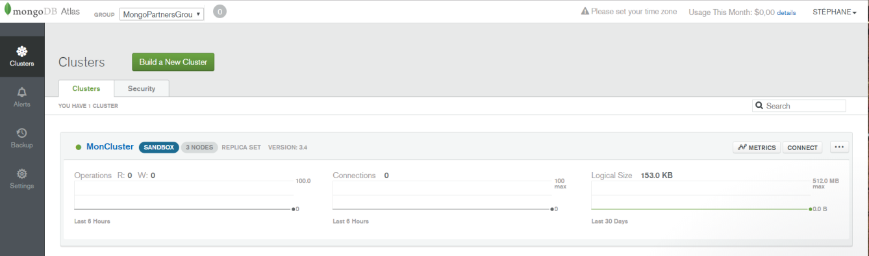

Then Mongo Atlas allows to easily manage the database since I have a GUI in order to create and manage users with different rights.

All I have to do is create a database with the MongoShell on the server.

The command is simply: **use {MyNewBaseName}** and then I have to create users in this base.

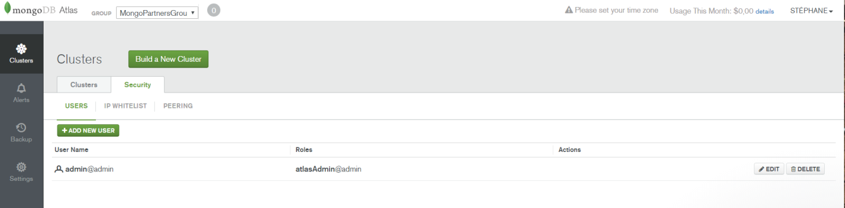

Finally, the configuration of the mup.js file changes a bit. Mongo's URL needs to be changed by the cluster's URL. Mondo DB Atlas gives us directly this URL:

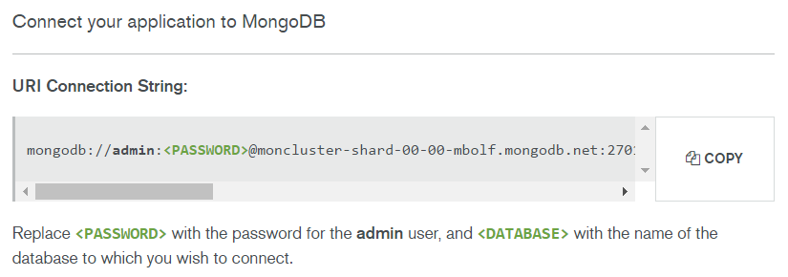

I will simply have to set the password defined for the user as well as the name of the database to which I want to access. It is indeed possible to create several databases on the same cluster.

**Cf APPENDIX** **4: MUP Configuration for a Mongo Atlas Utilization**

### Installing MongoDB on an Amazon EC2 cluster

This installation was more complicated to set up because I did not find a lot of documentation on the internet. It was first necessary to create an Amazon EC2 instance with the same procedure seen above. The only difference is that another kernel is chosen: **Amazon Linus AMI**

Then I will have to set up mongo and initialize the database on the instance with an SSH client.

**Here is the procedure that was used:**

1. Creation of a repos file for the use of yum and the installation of MongoDB (in server side with putty using SSH protocol): **sudo nano / etc/yum.repos.d/mongodb.repo**
2. Creation of the file where the data will be stored (the basic Mongo fact):

**mkdir -p /data/db**

1. Opening the mongo configuration file: **sudo nano /etc/mongod.conf**
2. Modifying the bind-ip to allow external traffic only from the server address
3. Launch of the database: **sudo service mongod start**
4. Launch of the MongoShell (**mongo**)
5. Creating the partners_database database with the MongoShell (**use partners_database**)
6. Creating an Admin user to connect to the database as an admin from outside (without using putty in SSH to the instance). I will also create Admin users for developer and access to the database from RobotMongo:

**db.createUser({ user: "Client", pwd: "mdpclientpartners", roles: [{ role: "clusterAdmin", db: "partner_database" }]})**

1. When the base is lunched, it is necessary to generate the new MONGO URI according to this format**:**

**mongodb://[username:password@]host1[:port1][,host2[:port2],...[,hostN[:portN]]][/[database][?options]]**

Once done, the configuration of the mup.js file is similar to the previous case, simply modifying the MONGO_URL.

## Google Play Store

Deployment could not be done on The Apple Store because it requires an Apple develop account that is paying year-round, as well as a MacBook.

I was able to do IOS accounting with a MacOS virtual machine, but deployment is impossible.

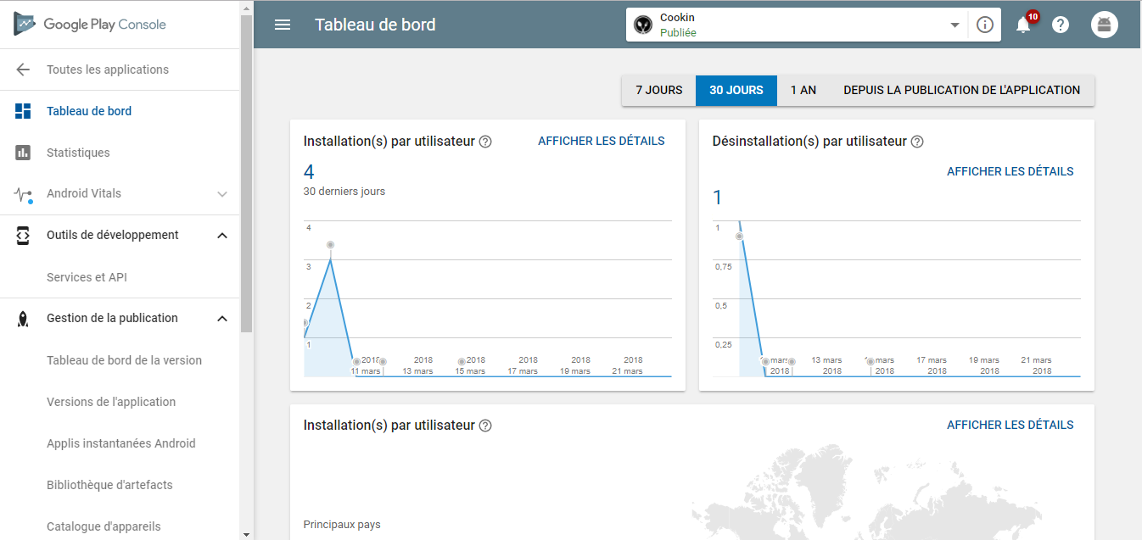

The app has been deployed to the Google Play Store for deployment testing. Payments are still fake because no company has been created, the user has the option to add a generic credit card to order menus.

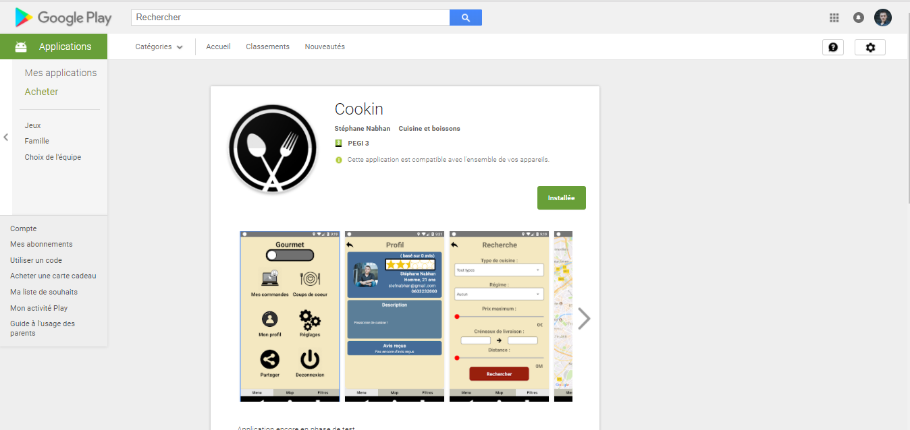

# monitoring

## Kadira

### Presentation of Kadira

Kadira is a tool set up by the Meteor community for monitoring a Meteor application.



It provided an efficient tool for monitoring and debugging the deployed server. Indeed, the response times of the methods as well as the pub / sub calls (to communicate with the client) were displayed.

The use of the CPU as well as the RAM are also displayed in real time, in order to optimize code as well as possible to manage the most possible customer connection.

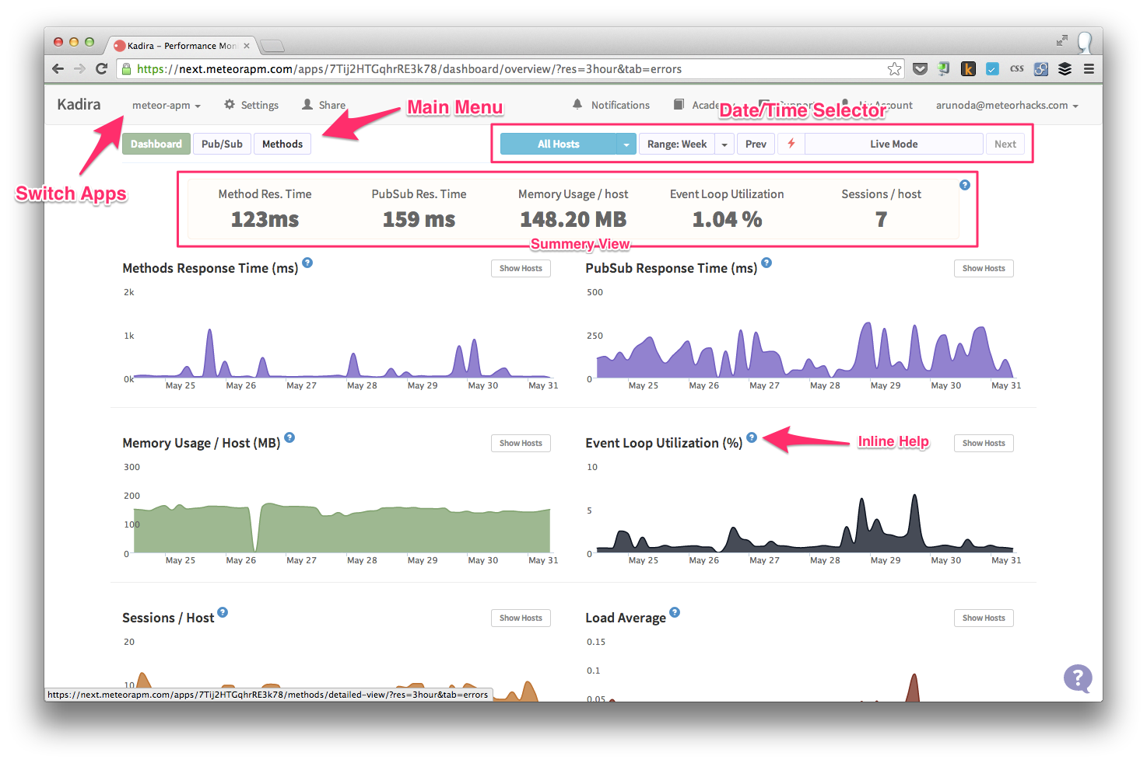

### Linking to our server

The connection with our application is done with the settings.json file generated by Meteor Up:

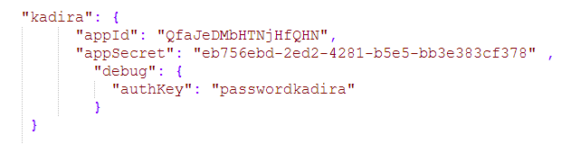

The appId as well as the appsecret are entered at this time to connect to our monitoring tool. The "authKey" field is useful for the debugging tool.

## Administration of the database

### Studio3T utilization

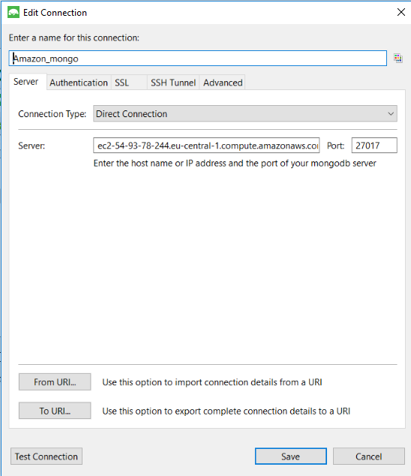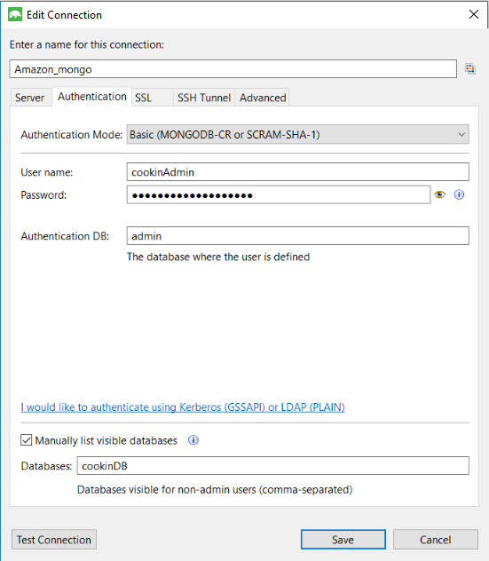

Access to the database instance with Studio3T is done by entering some necessary information:

• The public DNS address of the server instance containing our database

• The name of the database in this instance to be accessed

• A user ID with write and read permission (Users created earlier with the SSH client and the MongoShell)

• The password of the user in question

Once connected, the different collections of our database are displayed, and I can then easily access the different fields of each collection for reading or editing.

**Cf: APPENDIX** **5: Example of user fields in RobotMongo**

# results

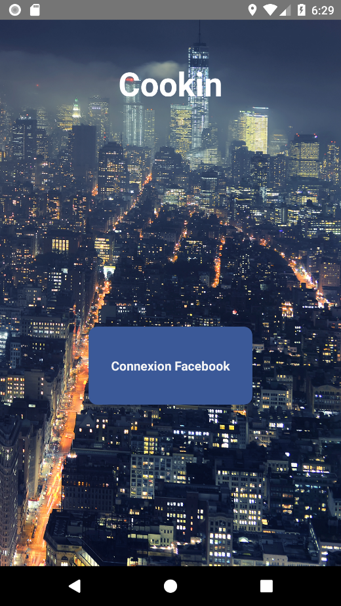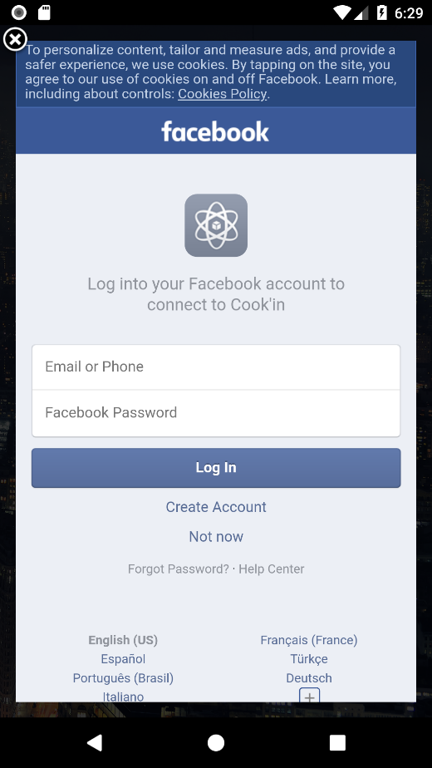

*SplashScreen Facebook Connection*

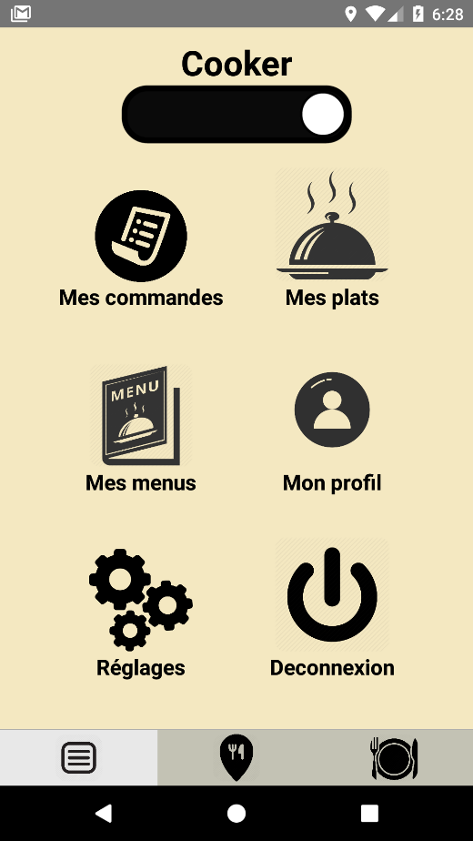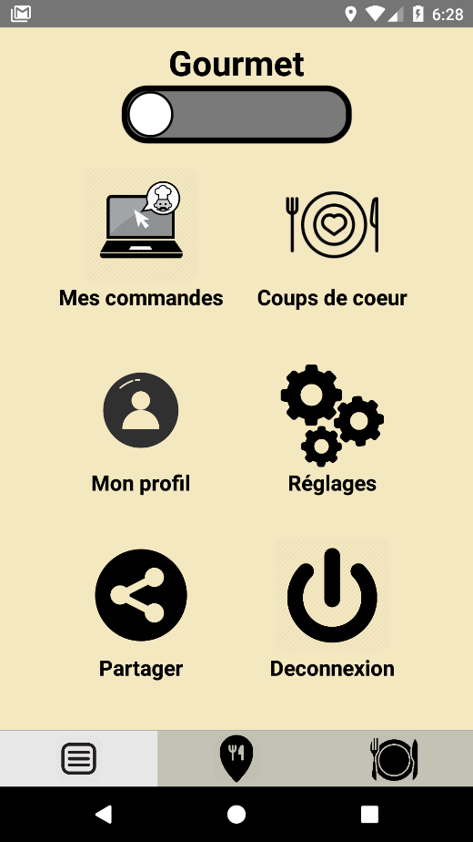

*Gourmet Menu Cooker Menu*

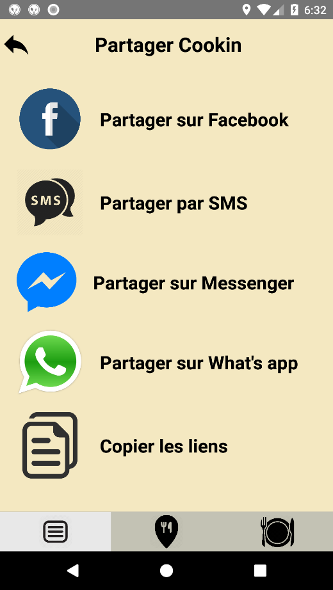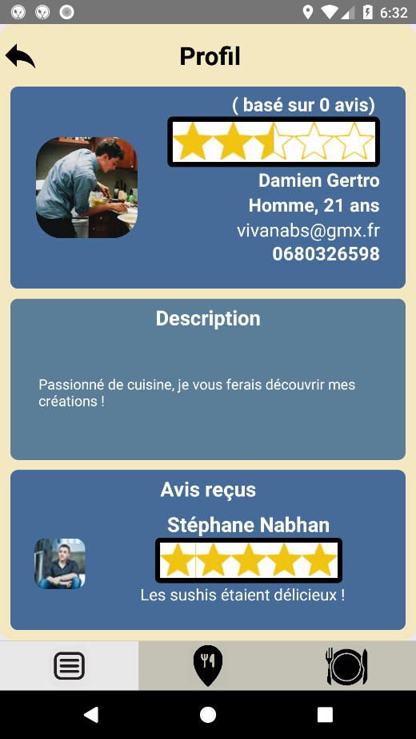

*Profile “Sharing App” Menu*

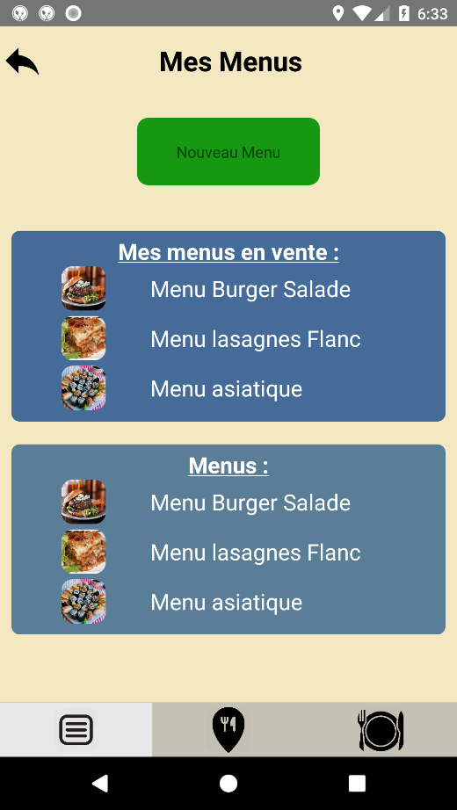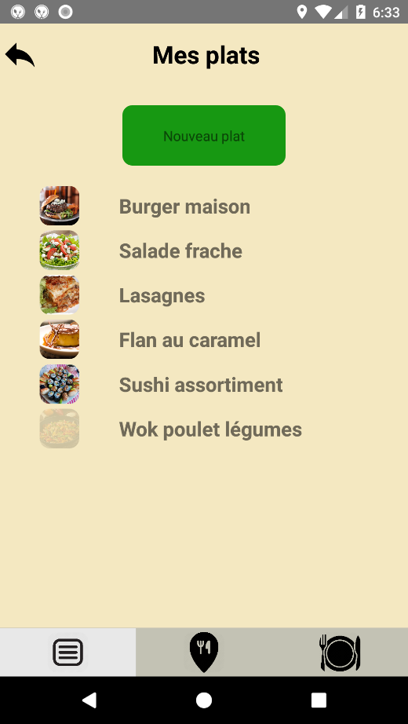

*My menus (available and locals) My Dishes*

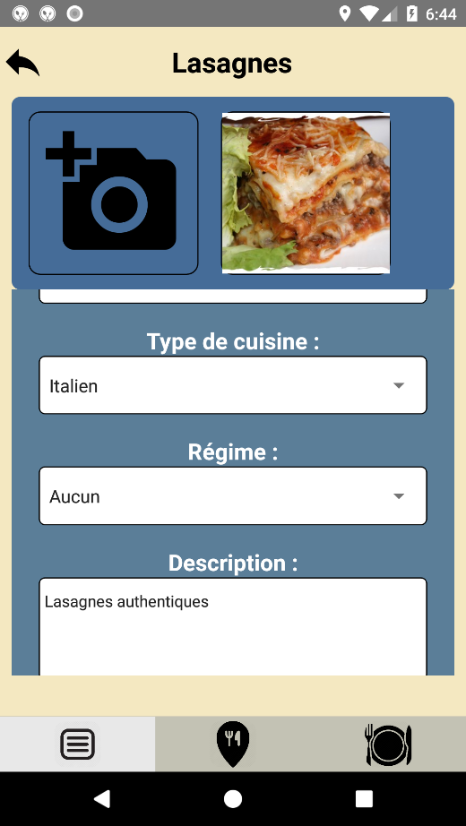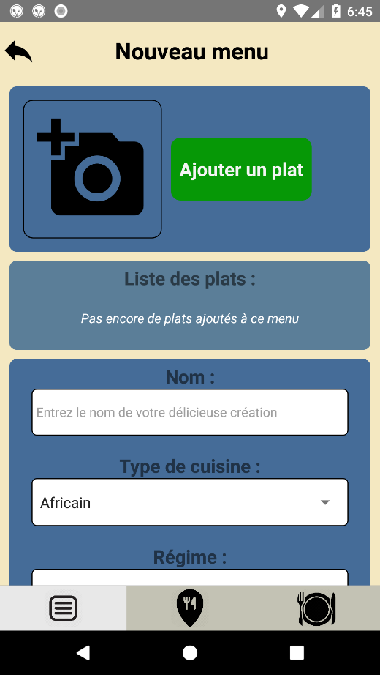

*Creating new menu Editing existing dish*

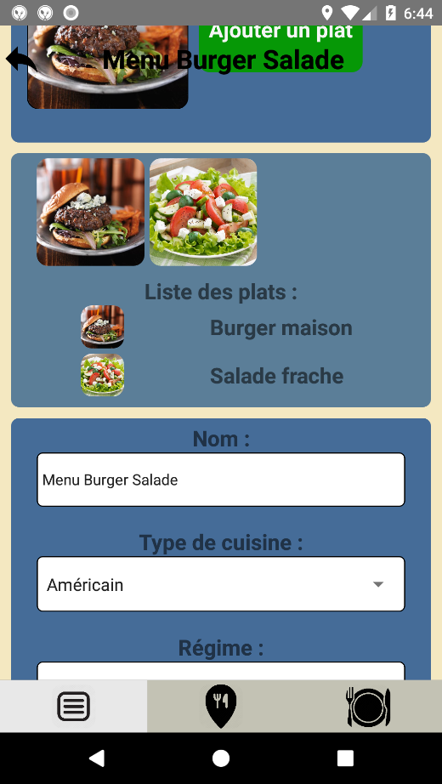

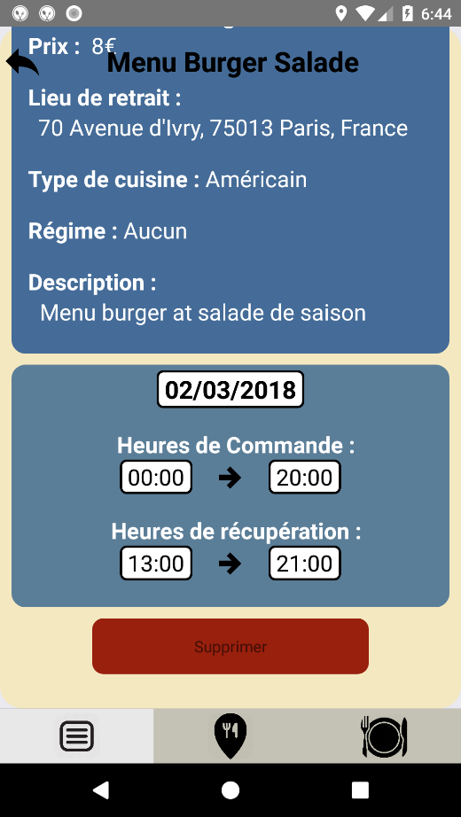

*Editing existing Menu View Available Menu (ability to remove it)*

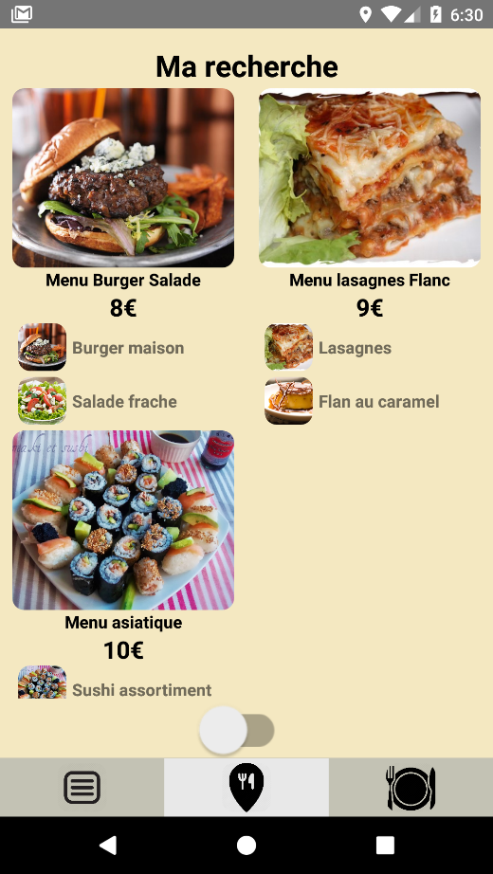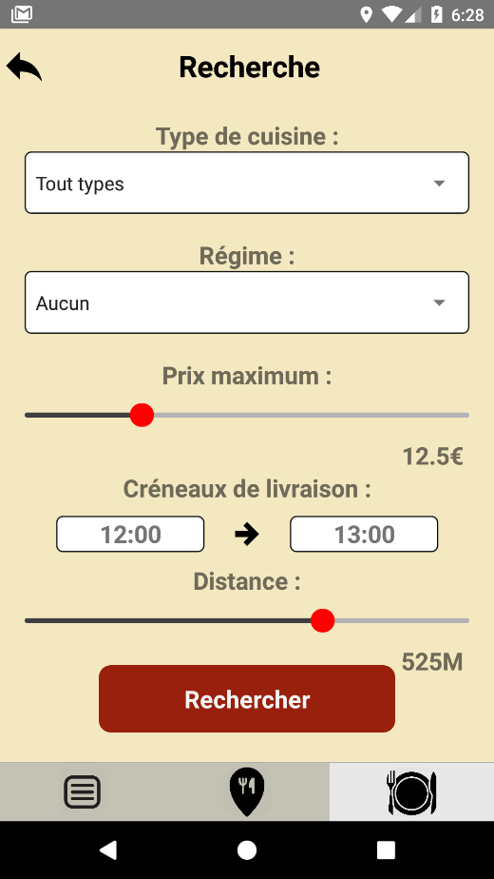

*Search available menu by criteria View results on grid*

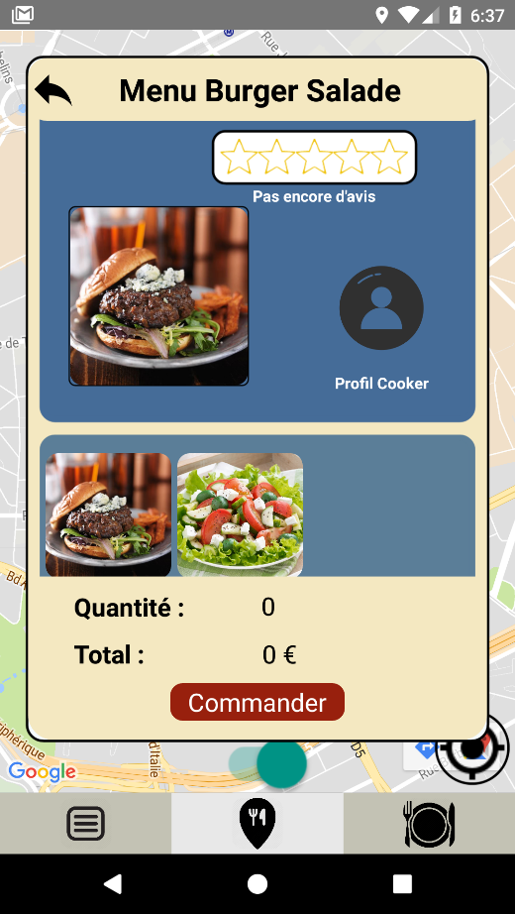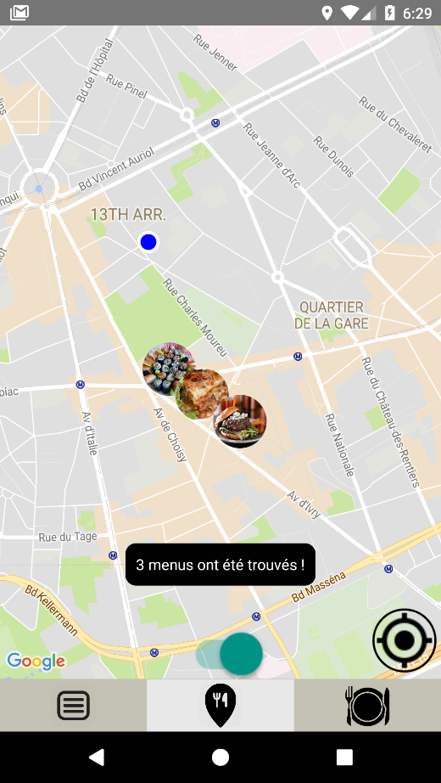

*View results on Map Display founded available Menu*

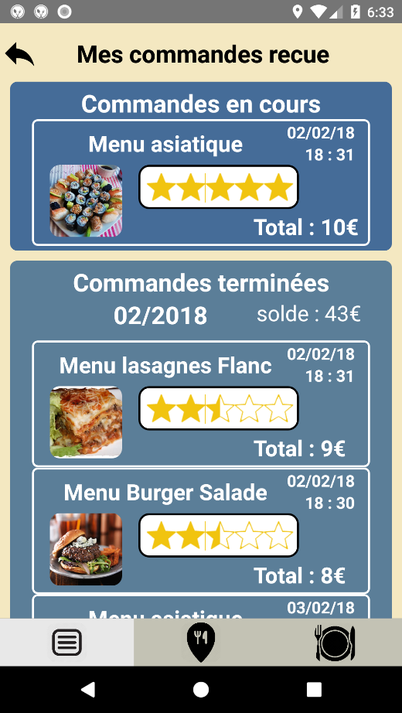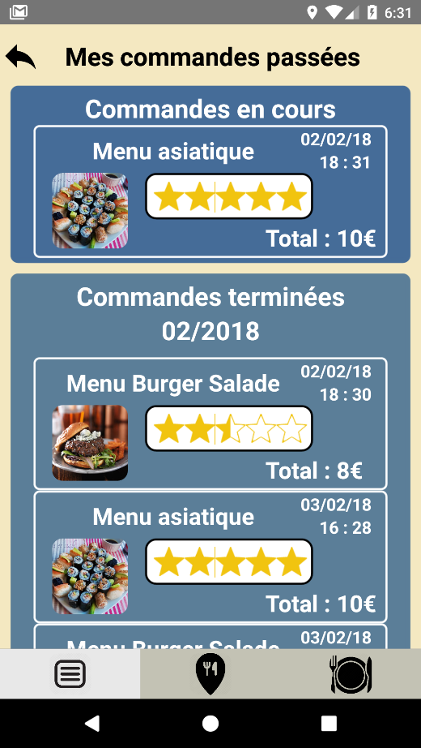

*View list made orders (Gourmet Mode) View list Received Order (Cooker Mode)*

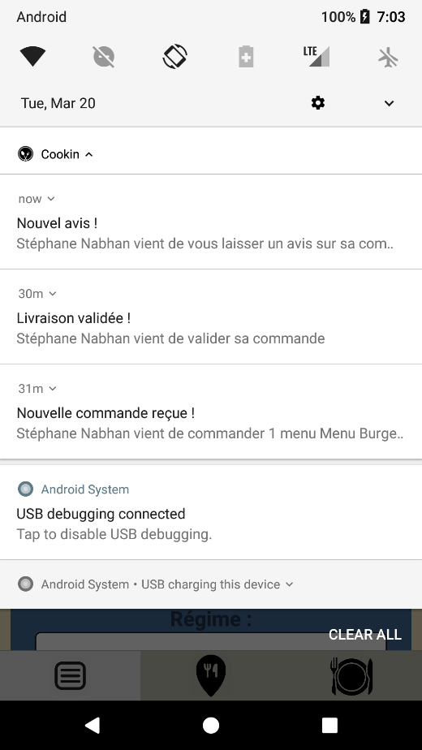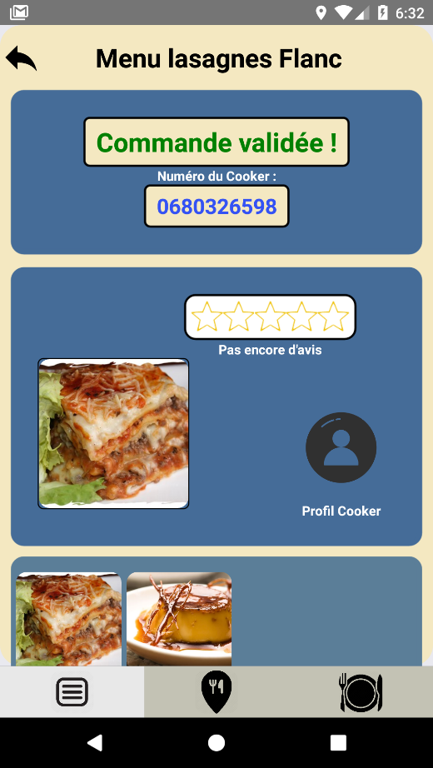

*Valid Order Notifications received by the Cooker*

# conclusion

To put it in a nutshell, I’ve learned many things with this project, first of all we’ve learned to work as team, to split the work and to deleguate to each other.

I also learned the process of developing an application from scratch, using several tools that I were not used to use like GitHub and how much work it represents to develop an application. Of course, I have learned a lot about React Native, Meteor and MongoDB but also JavaScript and how an application works with a server and a database.

There are few things that I could have done differently, in the beginning of the project I didn’t know if I wanted to do a Java Android application or something else and I lost some precious time finding out what was the “best” choice, I lost a bit of time divide the tasks in the beginning too.

Today the application is functional and in test phase. It is also present on the Google Play Store. Many perspectives are possible. The addition of machine learning for the recommendation and study of behavior, more social options with the aim of becoming a real community kitchen network.

It's a project that has the potential to become a startup. My prospects are now to try to develop that on my scale.

**Google Play Link:** <https://play.google.com/store/apps/details?id=com.cookin>

# literaTures

**One signal documentation and tutorials:**

<https://documentation.onesignal.com/docs>

<https://medium.com/differential/react-native-push-notifications-with-onesignal-9db6a7d75e1e>

<https://medium.com/differential/how-to-setup-push-notifications-in-react-native-ios-android-30ea0131355e>

<https://github.com/geektimecoil/react-native-onesignal>

**React Native’s Facebook documentation:**

<https://facebook.github.io/react-native/docs/getting-started.html>

**CSS’s flex box tutorial:**

<https://medium.com/the-react-native-log/understanding-react-native-flexbox-layout-7a528200afd4>

**Modules documentation:**

<https://github.com/djchie/react-native-star-rating>

<https://www.npmjs.com/package/react-native-simple-radio-button>

<https://github.com/tomauty/react-native-chart>

**React Native Meteor, OAuth with Facebook:**

<https://medium.com/differential/react-native-meteor-oauth-with-facebook-3d1346d7cdb7>

**CreateContainer & MeteorLisView component:**

[https://www.npmjs.com/package/react-native-meteor#createcontainer](https://www.npmjs.com/package/react-native-meteor%23createcontainer)

**Navigator react native component:**

<https://medium.com/react-native-training/react-native-navigator-navigating-like-a-pro-in-react-native-3cb1b6dc1e30>

**MongoDB operators:**

<https://docs.mongodb.com/manual/reference/operator/>

**Meteor documentation:**

<https://docs.meteor.com/>

**All tutorials from Cali Spencer:**

<https://medium.com/@spencer_carli>

**StarUml documentation:**

<http://staruml.sourceforge.net/docs/user-guide(en)/toc.html>

**StarUML example and tutorial:**

<https://www.clear.rice.edu/comp201/07-spring/info/staruml/>

**Amazon AWD documentation:**

<https://aws.amazon.com/fr/documentation/>

**Mongo Atlas documentation:**

<https://docs.atlas.mongodb.com/>

**Meteor Up Github Repos:**

<https://github.com/zodern/meteor-up>

# APPENDIX

## APPENDIX 1: Stylesheets

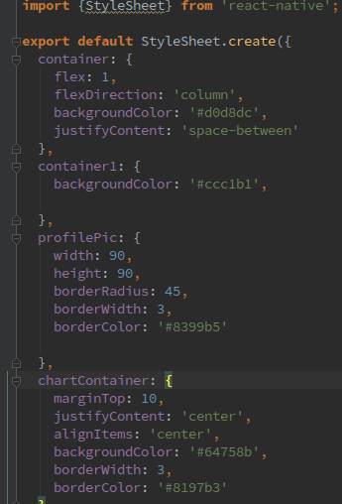

## APPENDIX 2: Communication Client - Server

**Send data from server to client:**

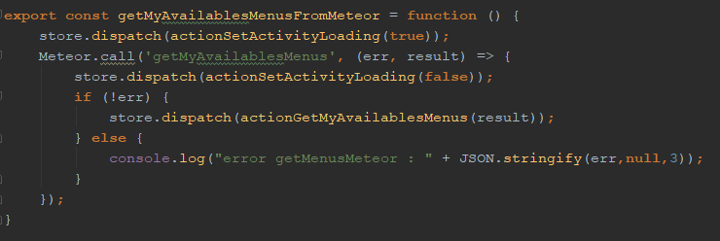

*Client side*

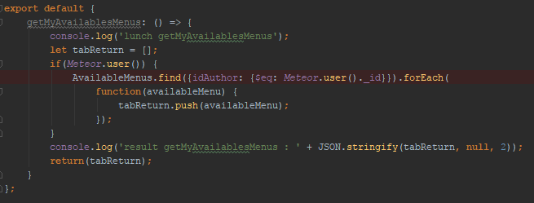

*Server Side*

**Send data from client to server:**

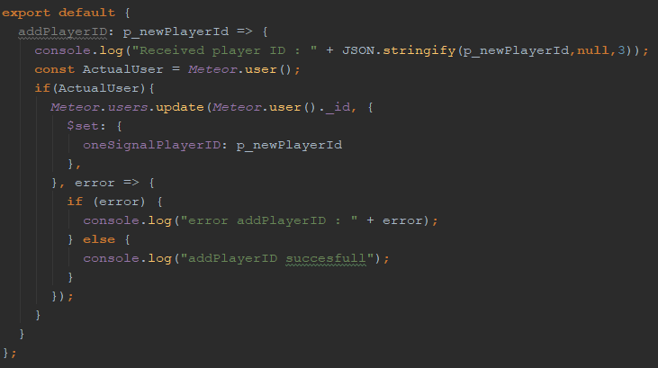

*Server Side*

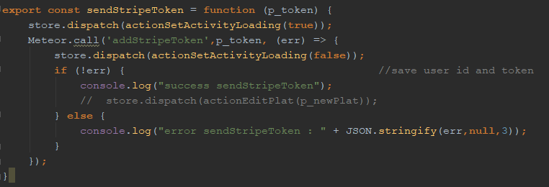

*Client side*

## APPENDIX 3: MUP Configuration for à local MongoDB

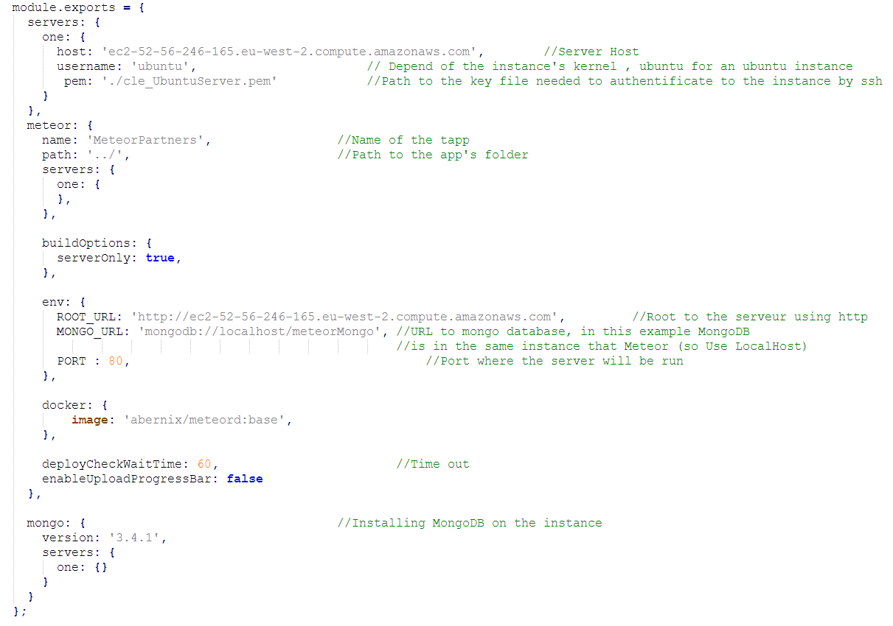

*As you can see, in this example I use localhost in the Mongo_URL because the database will be in the same instance that Meteor Server. In add, I choose which version of mongo I want to install.*

## APPENDIX 4: MUP Configuration for a Mongo Atlas Utilization

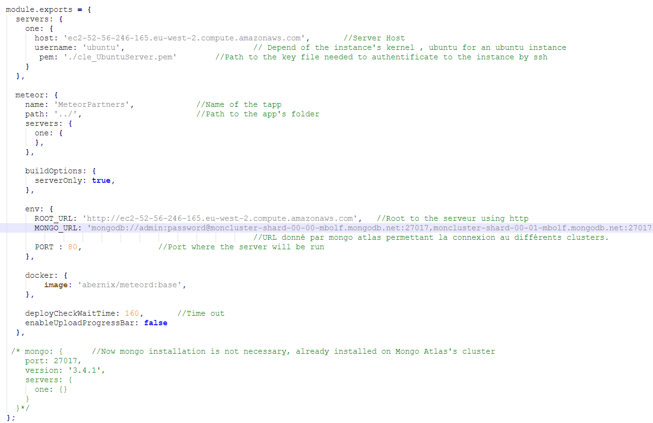

*As you can see, in this example I use the Mongo URI given in Mongo Atlas as Mongo_URL because the database will be instanced in Mongo Atlas's Clusters.*

## APPENDIX 5: Example of user fields in RobotMongo

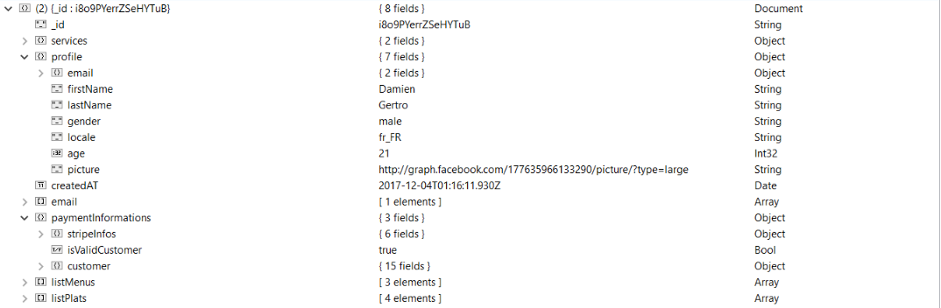

## APPENDIX 6: CreateContainer

To be able to import the createContainer function, there is a package meteor to add:

**meteor add react-meteor-data.** It allows to create a container component which provides data to your presentational components.

***Example:***

**export default** createContainer(params => {

**const** userId = Meteor.user()._id;

Meteor.subscribe('users', userId);

Meteor.subscribe('stats');

**return** {

userStatsExo: Meteor.collection('stats'),

accounts: Meteor.collection('users')

};

}, Scene);//will reactively rerender the wrapped component

In this example I want to find one user and all states entered by the users. So, to load the data I have to use the subscribe:

Meteor.subscribe('users', userId);

Meteor.subscribe('stats');

This will call a 'Meteor.publish' on the server side that will return a user corresponding to the userId parameter and also returns the statistics collection. And to use this data, I must specify the variable I want to return and specify the name of the presentation component.

**return** {

userStatsExo: Meteor.collection('stats'),

accounts: Meteor.collection('users')

};

}, Scene);

Here the presentational component is: Scene.

all data returned in the CreateContainer is Available in the presentation component (here is Scene)

As you can see I have transported data from server to client thanks to subscribe and a createContainer.

**MeteorListView Component:**

It’s like a listView: it is React-Native component who permit to render a list of data display in row. Whereas with the MeteorListView I don’t need dataSource, then I just need to specify on which collection I want to work and how I want to sort it:

<MeteorListView

enableEmptySections

collection="users"

options={{limit: 5}}

selector={{$and: [{_id: {$ne: userId}},{level: {$lte: Meteor.user().level+1, $gte: Meteor.user().level-1}}]}}

renderRow={**this**.renderRow}/>

</View>